Part 1: Identifying issues in code
Using the Python Debugger in Visual Studio Code, I ran the faulty code and identified the error. The Python Debugger tool pinpointed the exact character position where the exception occurred and gave me the exact reason for the exception (the TypeError listed at the bottom of the red message).
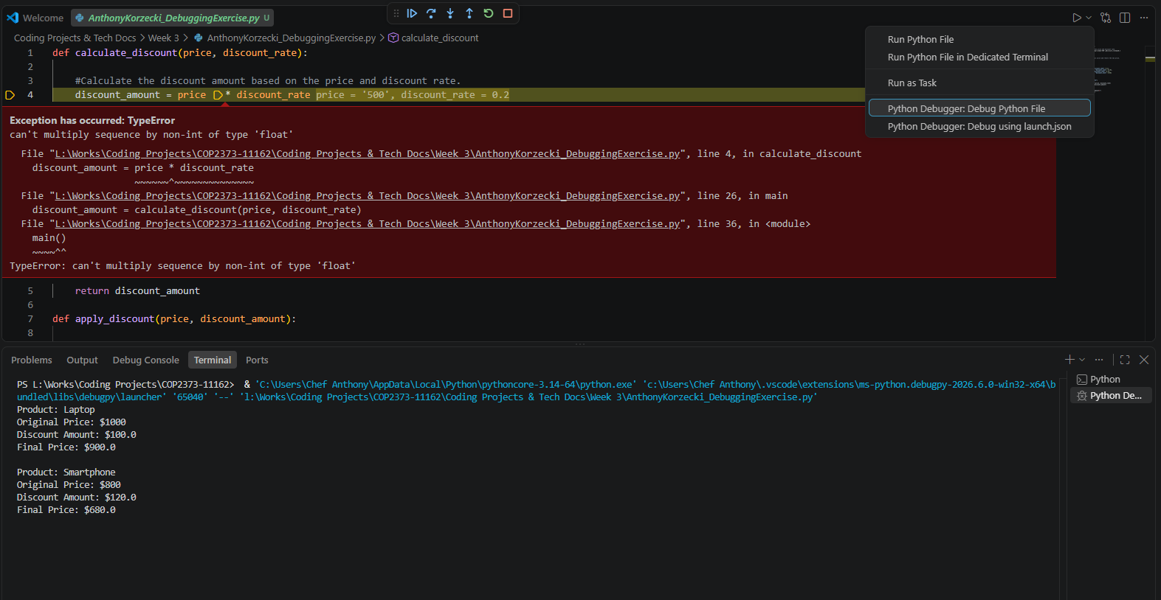
After seeing the TypeError message, I checked over the list of dictionary entries and noticed that one of the dictionary entries (the entry for the Tablet product) had its price entered in as a string, not as a float or integer. Before correcting the error, I decided to build out the exception handler and use the existing error to test it.

Part 2: Building the Error Handler
I used the Try/Except block schema suggested in the assignment directions to error handle. Specifically, in the Try block, I implemented an if statement that checks if the price and discount_rate dictionary entry values (which are passed into temporary variables of the same name) are legitimate integers or floats. If they are not integers or floats (each one can be either), the if statement triggers and causes a TypeError with my special error message to be raised.
My error message tells the user that the price and discount rate variables need to contain integers or floats and instructs them as to which variable(s) were not integers or floats. It then provides the user with a solution, instructing them to change any outstanding variables to integers or floats.
The error message is displayed past the Try block, at the very end of the for loop. It is not displayed in the middle of the Try block. While an error message could be hard coded into the if not statement, that would prevent the program from being able to handle multiple kinds of errors. By using a Try/Except block, multiple kinds of exceptions can be handled, and their messages/resolutions can be displayed. This creates a flexible architecture that allows me or anyone else who may work on this program in the future to seamlessly implement more exception handling.
Part 3: Testing the Error Handler
Testing the Error Handler was simple. I ran the broken code a few times using the standard Python Terminal in Visual Studio Code. During these runs, I isolated some grammatical issues and fixed them. Eventually, the Error Handler presented the error flawlessly, so I stopped testing it and called it complete.
Part 4: Fixing the Error
To fix the original error in the code, I removed the quotation marks from around the price of the Tablet product. This changed the price from a string to an integer. This fixed the issue.
Part 5: Further Improvements
More error handling could be added to this program, as I alluded to earlier. For instance, a similar if not statement can be implemented to make sure that there are valid strings in the product[‘name’] key-value pairs of the dictionary. Without user input, however, I don’t feel there’s a need for a large amount of error handling, especially in a program of this size. As long as the developer debugs their code before shipping to production, end users shouldn’t get any errors.

